Data Collection Committee (DCC)
18–20 November 2020
DCC-2020-Nov
(Virtual Meeting)

Proposal for considering
Draft E-Monitoring minimum data field standards
for Longline Transhipments
Discussion Paper 2
DCC-2020-Nov-DP-02

Background
The Transhipment Measure CMM2009-06 came into effect on 1 July 2011. It prohibits transhipment on the high seas, though longline, troll and pole and line vessels may be exempted if their flag CCM determines that this would cause significant economic hardship to the vessel. For vessels exempted that tranship at sea, CMM2009-06 also stipulates the minimum data required for a Transhipment declaration, it also requires all transhipments on the High Seas to be monitored by an observer.
Observers are deployed on carrier vessels to monitor longline transhipments but to date, there is no DCC standard data collection that produces data that can be usefully applied to cross-checking the catch by species recorded on logbooks, which is the main scientific and compliance objective in the monitoring of at-sea transhipments (reference : member country survey informing the EM LL Policy meeting, Oct 2019).
An FFA-commission study (see Brogan, 2020) produced recommendations for potential data fields and a protocol that could be implemented to obtain potentially useful data to cross-check the catch by species recorded on logbooks. MRAG (2018) provides a description of the protocol used by the IATTC for obtaining estimates of transhipped longline catch in the EPO, and has relevance to the enhancement of independent monitoring of transhipments in the Western and Central Pacific Ocean (WCPO).
The recent COVID pandemic and the constraints that it has placed on monitoring, has renewed discussion on the potential for E-Monitoring to provide a solution for at-sea transhipment data collection. With this in mind, there has been recent work conducted in the region looking at the potential of E-Monitoring to generate data that could be used to cross-check the catch by species recorded on logbooks (see 5. References).
Cognisant of the recent discussions on the increasing the priority, and the potential of E-Monitoring to provide a solution for at sea transhipment data collection, this paper attempts to tease out the information and recommendations, primarily provided in Brogan (2020) and MRAG (2018), to suggest a set of draft minimum Longline E-Monitoring data fields () for the review by DCC participants at the November 2020 meeting.
This paper acknowledges that Brogan (2020) has provided draft observer longline transhipment data fields and while the proposed draft EM minimum data fields in this paper are independent (at this stage), they have been closely aligned to the core data fields and protocols suggested in Brogan (2020).

Scope
The scope of this paper, and for subsequent discussion, amendments, and agreement of draft E-Monitoring minimum data field standards is as follows:
- This proposal acknowledges that the main objective of transhipment monitoring for science and compliance is catch validation of logbooks and other sources of data.
- Since these are draft DCC standards, the data collection will be restricted to FFA member country carriers and/or vessels that are licensed to FFA member countries. This scope is consistent with the other DCC data collection forms and standards but recognises that any DCC standard becomes a strong basis for taking forward to the WCPFC for consideration as a the basis for establishing the WCPFC standard.
- The area of coverage will be EEZ and high seas of the WCPFC Area.
- Brogan (2020) provided a comprehensive list of data fields that could be collected by a transhipment observer, including those that they are obliged to collect on other gear type(e.g. the compliance form). The scope of this initiative for E-Monitoring (at this stage), in line with the philosophy of WCPFC Project 93, only considers the main fields that could be best acquired through a potential E-Monitoring System implemented in the transhipment environment, and acknowledges that (i) there are difficulties collecting some fields that may be required and (ii) there are fields that are better acquired through other forms of data collection.
- This proposal also considers the efficiency of integrated systems in acquiring the required data, which is also in line with the WCPFC Project 93 philosophy. For example, the following would be considered primary requirements in a potential EM system to monitor and acquire data from the transfer of fish from fishing vessel to carrier:
  - a crane weighing scale (used in the transfer of fish from fishing vessel to carrier) which is directly integrated into the EM system (this requirement needs to be included in the EM equipment/system standards);
  - GPS position/date/time VMS from the EM system which is readily aligned to the regional VMS data so that the carrier and fishing vessel involved in the transhipment identified can be automatically generated, and the dates/positions of the transhipment events can be automatically generated (from the VMS data).

Approach by DCC to review the draft standards
This paper has been prepared specifically for DCC meeting discussion and the intention is to modify and enhance the draft standards based on the discussions and feedback provided by DCC.
This paper also acknowledges that the proposed data fields are initial, draft minimum standards which will need to be trialled, reviewed and adjusted in the initial stages of the EM trials. These are ‘minimum’ standards and based on what is understood to be both the primary data to be collected and data that can be realistically collected at this stage.
The proposed approach to reviewing this paper by DCC is as follows:
- The paper will be distributed before the DCC (Nov 2020) meeting so that participants will have read the paper and compiled comments before the meeting;
- With reference to this paper, DCC (Nov 2020) will consider the following
  - If there are additional fields to be added
  - If there are additional fields to be removed
  - If there are additional fields to be modified
  - Enhancing the notes on the proposed EM PROTOCOL
  - Agreeing on the finalised draft EM minimum standards for longline transhipments to take forward for trials
  - A basic plan for disseminating these draft standards and seeking interest in engaging relevant stakeholders (relevant member countries, EM technical service provider, funding agencies, FFA/SPC/PNAO) to work towards a trial

Proposed draft E-Monitoring minimum data fields for longline transhippment monitoring
The following information is based on the recommendations for transhipment data collection as proposed in Brogan (2020) and MRAG (2018), and to a lesser extent, information obtained from other sources (see 5. References). However, we reiterate that that many proposed observer transhipment data fields, listed in Brogan (2020), are not included in the proposed draft minimum data fields shown here based what we consider to be the main fields that can be realistically collected through EM, at this stage.

Figure 1 provides a diagrammatic representation of the structure of the proposed EM data collection during the transhipment of the longline fishing vessel to the carrier vessel, based on Brogan (2020).
In reference to Figure 1, the proposed longline transhipment data collection is structured through relationships between several “Entities”, as follows:

- A TRANSHIPPMENT EVENT is defined as the point when the transfer of fish from the fishing vessel to the carrier vessel starts to the point when the final transfer of fish from the fishing vessel to the carrier vessel has been completed, before the fishing vessel then leaves the carrier vessel. Transhippment events can be either a full transfer of catch onboard, or a partial tranship of catch onboard.
- A fishing vessel HATCH UNLOAD EVENT is defined as the entire unload of catch from a specific hatch on the fishing vessel to the carrier vessel. There may be one or many fishing vessel HATCH UNLOAD EVENTS within a TRANSHIPPMENT EVENT.
- A SWING PREPARATION EVENT is defined as a preparation for transfer of a group of fish (pulled from the hatch) and places in a net or through ropes, which are then attached to the hook on the crane, which is then ‘swung’ from the fishing vessel to the carrier vessel. There may be one or many SWING EVENTS within a designed HATCH UNLOAD EVENT.
- The SWING EVENT can have one or many SWING CONTENTS which is a breakdown of the components of each SWING by species and processing code.
- Individual fish from the SWING CONTENTS can be measured and this information is stored in the SAMPLE LENGTHS.
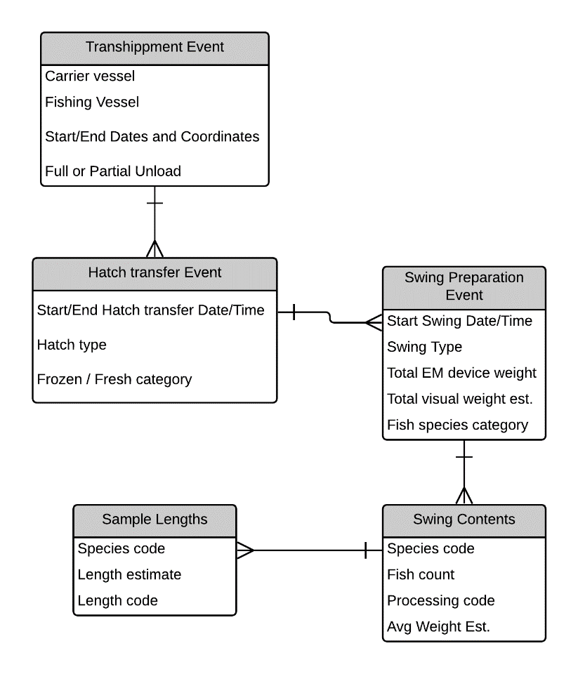
Figure 1. Proposed Longline Transhippment data collection structure
A list of proposed fields for each ENTITY is proposed below, with more detail in the table in ANNEX 1

Transhipment event
- Carrier vessel details (integrated VMS and FFA RFV)
- Catcher vessel details (integrated VMS and FFA RFV)
- Transhipment Start
  - Date/time and position
- Transhipment End
  - Date/time and position
- Full or partial unloading
- (Partial unloading details)
- Crane scale calibration details …

Hatch transfer event
- [transhipment event id – foreign key]
- Start / End Date time of fish unloaded from the hatch
- Hatch type
- Hatch number/identifier
- Frozen / Fresh category

Swing preparation event
- [Hatch event id – foreign key]
- Start / End Date time and positions
- Type of ‘swing’ : NET or use of ROPES of fish
- Total electronic crane scale weight (crane scale device integrated with EM system)
- Total visual catch estimate ?
- Fish species category

Swing contents
- [Swing event id – foreign key]
- Species code
- Fish count
- Processing code
- Average weight estimate [visual]

[Sample lengths]
- [Swing event id – foreign key]
- Species code
- Length
- Length code

The potential to collect useful length samples through EM needs to be validated for a number of reasons, including
- Can the species be readily identified ?
- What would be a useful length measurement given the tails are usually removed ?
- Is it possible to calibrate the EM digital measuring tool to provide accurate measurements ?

For this reason, we have bracketed the requirement to collect individual fish length data and this will need to be discussed with the respective EM technical service provider. The requirement for individual fish size data is (i) to provide a more precise estimate of average weight by species and (ii) contribute size data to the stock assessments (although, on-board observers and port sampling are currently contributing the size data for stock assessments).
There are potential compliance fields that could also be suggested, including the presence of tori poles (where this level of monitoring is required/relevant) and monitoring of MARPOL issues.

Notes on protocols, coverage, and analysis rates
The following are (non-exhaustive) notes that should be considered when developing the protocols, coverage and analysis rates for E-Monitoring of longline transhipments.
- Consistent with Project 93, these draft EM standards are proposing integration with other sources of information and the specifications and protocols should provide the necessary level of detail to ensure the third-party service providers are aware of the requirements. For example, these standards are recommending the integration of the EM system with Regional VMS to ensure the “transhipment event” data can be automatically generated rather than manually entered/determined by the EM Analyst. For example, this could be achieved through the Regional VMS identifying all potential transhipment events around the date/time/position indicated in the EM system (when the integrated EM data/video is first available to the EM Analyst) so that the EM Analyst can merely select the relevant transhipment event to auto-generate the fields : Carrier Vessel, Fishing Vessel, transhipment start date/time/position, transhipment end date/time/position.
- These standards require that the motion-compensating crane scale is an integral part of the EM system and that the integrated EM system will have a mechanism for automatically generating the best estimate of the weight of each swing event. If this is not possible in the short-term, it should be a priority for mid-long term R&D for the technical service provider.
- Since the main objective of transhipment monitoring is catch validation, the EM analysis rate should perhaps consider the monitoring of ALL swing events from SELECTED transhipment events to ensure determining the independent trip catch as accurate as possible to compare with the logbook data. However, this protocol would be different to onboard transhipment observer monitoring where it is not feasible to monitor ALL swing events
- …

References
Blaha, F. and K. Whitaker. 2020. Development of Draft Competency Standards to Cover monitoring of Unloading/transhipment in Port and at Sea. FFA commissioned study
Brogan, D. 2020. Standardised Monitoring Procedures for Longline Transhipments in the WCPFC. FFA and SPC study, funded by PEW Charitable Trusts.
DCC. 2017. Outcomes from the Second Regional EM Process Standards Workshop (REMPS-2). SPC Headquarters. Noumea, New Caledonia. November 2018. SPC and FFA.
Heberer, C. 2020. Electronic Monitoring on transshipment vessels operating in the Western and Central Pacific Ocean Longline Tuna Fishery. TNC (The Nature Conservancy) Report.
MRAG Americas Inc. 2018. Review of the IATTC Regional Observer Programme, covering the period January 1, 2017 to February 15, 2018. IATTC CAF. DOCUMENT CAF-06-03 ADD. 1.
PEW Charitable Trusts. 2019. Transhipment in the Western and Central Pacific Report. WCPFC-TCC15-2019-OP05. WCPFC Technical and Compliance Committee (TCC15) Observer paper.
WCPFC. 2018. E-Reporting Standards for high seas transhipment declarations and high seas transhipment notices. https://www.wcpfc.int/doc/data-06/e-reporting-standards-high-seas-transhipment-declarations-and-high-seas-transhipment.

ANNEX 1. Draft Longline Transhipment minimum data field standards
These standards are proposed for member countries to consider for E-Monitoring trials for Longline transhipments at sea (or in port). These draft standards are intended to form the basis of discussions with potential EM technical providers for establishing an EM system to obtain/generate minimum data fields for longline transhipments at sea, acknowledging that the EM Protocol notes provided below would need to be expanded during these dsicussions. These standards are in draft format and will be reviewed from time to time.
SPC/FFA/PNA DCC LL Transhipment minimum data fields |  | Description | Notes on EM PROTOCOL (How the data are to be acquired by EM Analyst)
VESSEL IDENTIFICATION
Carrier Vessel identification | Name of vessel | Name of vessel. This information would normally be linked to a VESSEL reference database (e.g. FFA Vessel Register) which will ensure consistency/standardisation. | The EM system should have linkages into the regional VESSEL REGISTERs (WCPFC and/or FFA) and so these fields must be generated by the EM system to be consistent with these vessel registers.  The integration of the EM system with Regional VMS to ensure the “transhipment event” data can be automatically generated rather than manually entered/determined by the EM Analyst. For example, this could be achieved through the Regional VMS identifying all potential transhipment events around the date/time/position indicated in the EM system (when the integrated EM data/video is first available to the EM Analyst) so that the EM Analyst can merely select the relevant transhipment event to auto-generate the fields : Carrier Vessel, Fishing Vessel, transhipment start date/time/position, transhipment end date/time/position.
 | Flag State Registration Number | Flag registration number of the vessel
 | Flag | Flag or chartering nation of the vessel
 | International Radio Call Sign | International Call sign
 | WCPFC VID, FFA VID and IMO | IMO, WCPFC Vessel ID and the FFA VID would be generated by the EM system using these VESSEL reference databases.
Fishing r Vessel identification | Name of vessel | Name of vessel. This information would normally be linked to a VESSEL reference database (e.g. FFA Vessel Register) which will ensure consistency/standardisation. | (see above approach for Carrier Vessel identification; the same would apply for Fishing Vessel identification)  The integration of VMS system and the regional vessel registers can potentially automatically generate this information, in addition to the VMS system integrated in the EM System. This concept is in line with Project 93, that at sea boarding inspectors (for e.g.) are acknowledged to best placed to verify this information.  These data fields could therefore be available in the EM system before the EM Analyst starts their work, and the EM Analyst may provide some verification if required.
 | Flag State Registration Number | Flag registration number of the vessel
 | Flag | Flag or chartering nation of the vessel
 | International Radio Call Sign | International Call sign
 | WCPFC VID, FFA VID and IMO | IMO, WCPFC Vessel ID and the FFA VID would be generated by the EM system using these VESSEL reference databases.
 | TRANSHIPMENT EVENT
Transhipment Event | Transhipment Start Date and time | The date and time the transhipment between carrier and fishing vessel starts. | The EM system may be able to automatically identify this point in time through AI or sensors, otherwise it should be detected by the EM Analyst from the video.
 | Transhipment Start - Position (Latitude and longitude of the carrier when the at sea transhipment starts) | GPS reading for the start  of the ‘at sea’ transhipment from the carrier to a fishing vessel will be generated. | Auto-generated by the EM system from the float SET timestamping. Minimum resolution of position is 1/1000 of a minute.
 | Transhipment End Date and time | The date and time the transhipment between carrier and fishing vessel ends. | The EM system may be able to automatically identify this point in time through AI or sensors, otherwise it should be detected by the EM Analyst from the video.  Consider whether there is merit in also recording the stop, restart information.
 | Transhipment End - Position (Latitude and longitude of the carrier when the at sea transhipment ends) | GPS reading for the end  of the ‘at sea’ transhipment from the carrier to a fishing vessel will be generated. | Auto-generated by the EM system from the float SET timestamping. Minimum resolution of position is 1/1000 of a minute.
 | Full or Partial transhipment | Indicates whether the full (entire) trip catch from the fishing vessel was transhipped or not. | This may not be evident to the EM Analyst and some indicators would need to be proposed. We also recommend the inclusion of a comments field to explain what catch was transhipped and what catch remained on the fishing vessel, in the case of partial transhipments.  This is a key field and needs some thought as to how it can be collected through EM.
 | EM ANALYSIS INFORMATION
EM Analysis | EM Analyst name and code | EM Analyst's name and EM Analyst code. | Entered into EM system by EM Analyst. The EM Analyst code should correspond to the regional EM Analyst code reference table.
 | EM Country provider (EM data review centre) | EM programme provider code - data review centre - e.g. FJEM (Fiji E-Monitoring Programme) | Entered into EM system by EM Analyst. It should adhere to the format "xxEM" where xx is the ISO two-letter country code of the EM data centre, and appropriate two-letter codes for any sub-regional programme.
 | EM Data Quality Reviewer | EM Data Quality Reviewer. | Entered into EM system by EM Analyst (free format text). The EM data quality review SSPs have yet to be established and agreed.
 | EM Data Quality Review conducted | EM Data Quality Review has been conducted (Y/N) | Entered into EM system by EM Reviewer. The EM data quality review SSPs have yet to be established and agreed.
 | TRANSHIPMENT coverage strategy | TBD | TBD
 | EM Technical service provider | EM system technical service provider | Generated from EM system
 | EM system software name and version | EM software name and version | Generated from EM system
 | HATCH TRANSFER INFORMATION
Haul Transfer Information | Hatch Number/ identifier | A number or identifier for the hatch on the fishing vessel | Provided by the EM Analyst. (To be determined / elaborated).
 | Date & time start of HATCH TRANSFER | Date and time when fish are first removed from this HATCH | Auto-generated by the EM system from the HATCH unload start and end timestamping.
 | Date and time of end of HATCH TRANSFER | Date and time when last fish are removed from this HATCH
 | Hatch TYPE | Type of Hatch/storage (ULT or normal or ??) | Provided by the EM Analyst. (To be determined / elaborated).  (Could be obtained from Vessel register, port inspection, at sea inspection and so not needed here)
 | Carrier Hatch | A number or identifier for the hatch on the CARRIER vessel | Provided by the EM Analyst. (To be determined / elaborated).
 | SWING PREPARATION EVENT INFORMATION
Swing event information | Date & time start of Swing event | Date and time when fish are prepared on the crane for ‘swinging’ from fishing vessel to the carrier vessel | Auto-generated by the EM system from timestamping of when the start of preparation of fish on the crane for the ‘swing’ occurs
 | Type of Swing | ROPES of fish collected on the crane, or a NET holding the fish | Provided by the EM Analyst. (To be determined / elaborated).
 | Swing weight | Total estimated weight (kgs) of fish attached to the crane that is swung from fishing vessel to carrier vessel | 1. Motion-compensating crane scale integrated into the EM system  2. Estimated by EM Analyst through count of fish (through count of fish or ropes) multiplied by the estimated average weight (obtained through one of the methods similar to that proposed in the MRAG-IATTC transhipment protocols)  3. Visual estimate
 | Swing weight method | Method used to determine (Swing weight) | (see above)
 | Fish species category | Either the fish species or the category of fish. For example, ALB if all fish in the ‘swing event’ are albacore tuna. YFT/BET if there are a mix. | Provided by the EM Analyst. (To be determined / elaborated).
 | SWING CONTENTS INFORMATION
Swing contents information | Species code | FAO code of species caught | EM Analyst declaration. Must use the FAO standard Species codes.  There may be more than one species in this swing event, and there should be entries of the following fields for each species or species group in each swing event.
 | Fish count | Count of fish of this species in the SWING EVENT | EM Analyst declaration. To be obtained through :  1. Count of fish in the net from video  2. Count of ropes (by species) x average number of fish per rope (in cases where there is more than one fish per rope)
 | Processed Code | The code for the processed state of this species | EM Analyst will provide the relevant processing code relevant to this species grouping.  WW – whole  GG – Gilled-and-gutted  GT – gilled-gutted and tailed  FW – filleted  LW – Loin weight …
 | Average weight | Average weight of this species in this swing event | Refer to potential methods in the MRAG-IATTC transhipment protocols.  Could include :  1. Average of individual fish sample weighed using motion-compensating scales  2. Using the SAMPLE LENGTHs (see below) converted to WEIGHT  3. Estimated by the declared WEIGHT divided by the declared NUMBER  4. Visual estimate  5. …
 | SAMPLED LENGTHS (if feasible)
Sampled lengths | Species code | FAO code of species caught | EM Analyst declaration. Must use the FAO standard Species codes.  Only a sample of the swing events are selected for length measurements, if feasible  Sampling protocol (e.g. how many fish, which fish can be randomly selected, etc.) needs to be established. In this regards, the MRAG-IATTC protocol could be considered.
 | Length of fish | Measure length of species using the recommended measurement | EM Analyst using the calibrated digital measuring tool, noting the need for an assigned area on the deck where the fish should be measured.
 | Length measurement code | Code the type of measurement used | EM Analyst declaration depending on how the fish was measured. Must use regional standard codes for LENGTH CODES

https://oceanfish.spc.int/en/meetingsworkshops/e-reporting-a-e-monitoring/499-e-monitoring-oct-2019
See also the ICCAT, IOTC and IATTC Observer manual (MRAG, 2019) at https://www.iccat.int/Documents/ROP/ICCAT_Observer_Manual.pdf
Another type of monitoring, yet to be explored, is the monitoring of carrier offloads of longline catch back at port. This type of monitoring would need to ensure the unloaded longline catch (at port) could be traced back to the fishing trip, which is consistent with the purse seine (ISSF) cannery receipt data.

