Data Collection Committee (DCC)
18–20 November 2020
DCC-2020-Nov
(Virtual Meeting)

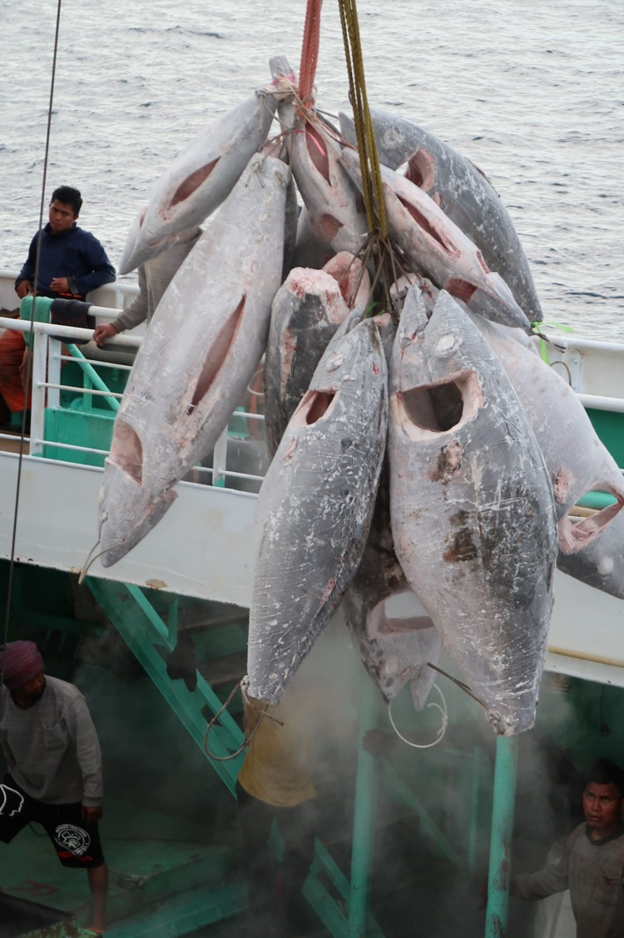
D. Brogan.

Draft guidelines for
Generic Minimum Data Standards in
Longline Transhipment Monitoring

Discussion Paper 3
DCC-2020-Nov-DP-03

Draft v1.0

background
The WCPFC Convention recognises the importance of independent monitoring vessel unloading to verify reported catches. However, while the Convention bans single purse seine transhipments outside of port except if exemption is granted by the Commission, it is less restrictive for longline and other gear types:
“to support efforts to ensure accurate reporting of catches, the members of the Commission shall encourage their fishing vessels, to the extent practicable, to conduct transhipment in port (Article 29 [1]).
The MRAG 2016, report of the Quantification of IUU fishing in the Pacific Islands Region identified the main sources of IUU catch in the tropical tuna longline fishery were:
“largely driven by misreporting (49% of total TLL volume) and post-harvest risks (39%), principally illegal transhipping”
Independent monitoring of the tropical longline fishing operations is low with a WCPFC Regional Observer Programme minimum requirement of 5% observer coverage (CMM2018-05). This is well below that required for accurate statistically projected catch composition (Lawson, 2004, 2005). Thus an integrated system of other supplementary sources to verify catch is required, effective transhipment monitoring being a critical one.
To improve verification of catch estimates, the Conservation and Management Measure on the Regulation of Transhipment (CMM2009-06) came into force on the 1st of January, 2011. The purpose of the measure is:
“to establish procedures to obtain and verify data on the quantity and species transhipped in the Convention Area to ensure accurate reporting of catches, and enhance stock assessments of highly migratory fish stocks.”
To ensure all transhipments are monitored fully, under CMM2009-06 there
“shall be no transhipment on the high seas except where a CCM has determined, … that it is impracticable for certain vessels that it is responsible for to operate without being able to tranship on the high seas, and has advised the Commission”
However, despite CMM2009-06 making high seas transhipments an exception requiring flag CCMs to determine that it is impracticable to operate without being able to tranship in the high seas, most vessels have received this exemption. Wold (2018) noted that for 2019, more that 50% of longliners and other non-purse seine vessels were registered to tranship on the high seas. The number of vessels is increasing, as at 30 June 2020, 2187 out of 3503 vessels (62 %) on the Record of Fishing Vessels (RFV) flagged to 9 CCMs are authorised to tranship in the high seas (WCPFC-TCC16-2020-RP03).
There is a corresponding trend to increasing numbers of transhipments on the high seas (In 2019 there were 1472 high seas transhipments from 503 vessels, the highest recorded under the measure. To the 30th June 2020 there were 725 transhipments, indicating this use of the exemption is continuing despite CMM2009-06 requiring flag CCMs to provide a plan detailing what steps they are taking to encourage transhipment to occur in port (CMM2009-06 para 35 v.).
More importantly a large proportion of the region’s catch is being transhipped at sea, which precludes other important demographic data being collected on a significant proportion of the regions catch in certain fisheries. To the end of July in 2020, 34% of bigeye and 27% of albacore declared catches were transhipped on the high seas (WCPFC-TCC16-2020-RP03). So despite the requirement for transhipments to occur in port, there has been an increasing number of high seas transhipments with increasing proportion of catch transhipped on the high seas rather than in port. This trend emphasizes the need to establish effective transhipment monitoring, especially for those occurring on the high seas to ensure reliable catch estimates.
However, despite the impact of COVID on observer monitoring coverage of fishing operations monitoring of transhipments has continued, of the 409 reported transhipments that took place between 1 April and 18 August 2020, only 11 (around 3 %) were not observed (WCPFC-TCC16-2020-RP03).
Currently the PICTs that do have observers on transhipment vessels use the WCPFC forms, though these are non-compulsory. However there are no current minimum standards for what an observer (or other transhipment monitoring entity). This is an opportunity for the SPC/FFA/PNA Data Collection Committee to establish standards of independent transhipment monitoring for all longline operations.
Objective
This paper has been prepared specifically for DCC meeting review and discussion with the intention to work towards agreement of generic minimum data standards in Longline Transhipment Monitoring that can be applied to each potential source of data.

Monitoring Requirements
Currently the primary source of transhipment information to verify declared catch is through the WCPFC Transhipment Declarations. CMM 2009-06 requires a Transhipment Declaration to be completed by both the offloading and the receiving vessels for each high seas transhipment in the Convention Area and each transhipment of catch taken in the Convention Area.
The WCPFC Transhipment Declaration requires the following information:
- A unique document identifier
- the name of the fishing vessel and its WIN,
- the name of the carrier vessel and its WIN
- the fishing gear used to take the fish
- the quantity of product (including species and its processed state ) to be transhipped
- the state of fish (fresh or frozen)
- the quantity of by-product to be transhipped,
- the geographic location of the highly migratory fish stock catches
- the date and location of the transhipment
- If applicable, the name and signature of the WCPFC observer
(CMM2009-06 Annex 1.)

The monitoring of the transhipments in CMM2009-06 is through 100% observer coverage of transhipments, with the observer generally being deployed on the carrier receiving vessel (CMM 2009-06 para 13). The role of the observer is largely to verify the transhipment declaration information and they sign the declaration.
The role of the observer monitoring the transhipment includes confirming to the extent possible that the transhipped quantities of fish are consistent with other information available to the observer, which may include:
- “the catch reported in the WCPFC Transshipment Declaration;
- data in catch and effort logsheets, including catch and effort logsheets reported to coastal States for fish taken in waters of such coastal States;
- vessel position data; and
- the intended port of landing.”
(CMM2009-06 para. 14)
However the observer monitoring system for longline transhipments needs to collect and record required data independently of the carrier and fishing vessel’s declaration. This would usually be done by using an independent and verifiable data collection protocol. The transhipment observer currently uses paper forms or potentially using ER, but could also consider integrated systems including EM.
The PICT observer programmes that (voluntarily) monitor transhipments in WCPFC, and the (mandatory) transhipment observer programmes operated by MRAG under the IATTC, IOTC and CCSBT all use paper forms. However, there is also a lot of data that are collected by the observer but not actually independently collected, eg. Vessel size, length, or fields that could be calculated elsewhere average weight, etc.
The WCPFC transshipment IWG (TSIWG) is currently considering the ‘Scope of Work for the Transhipment Information Analysis in Support of the Review Of CMM 2009-06’. In this analysis data collected from transhipment declarations and by transhipment observers will be analysed. One of the proposed outputs will be to find data gaps that impeded the effectiveness of regulating and monitoring transshipment activity, and propose data fields to improve the effectiveness of regulating and monitoring transshipment activity.
This paper is therefore an attempt at rendering down the current fields collected by these monitoring programmes and the transhipment declarations into key information needed for the purposes of independent monitoring of longline transhipments to improve the verification and validation of catch transferred and thereby to better quantify the actual longline catch to support stock assessments and the application of management measures.

Caveat
Noting that the exemption loophole to allow high seas transhipments has been over exercised by DWFNs. The study by Wold (2018) ‘The Impracticability Exemption to the WCPFC’s Prohibition on Transhipment on the High Seas’, submitted to TCC14 by the Marshall Islands as WCPFC-TCC14-2018-DP05, highlights the intention to cease this practice. Longline transhipments in port allow for a greater suite of monitoring tools to be used as an integrated system
This proposed set of minimum data standards is not intended to support transhipments out of designated ports or to derogate the intention of FFA coastal states to ensure longline transhipments occur in designated ports. The data should be viewed as the minimum required for its primary role of verification of catch to mitigate IUU issues in the high seas longline fishery and to support stock assessment and assessing management measures. These minimum data standards should apply to all transhipments whether collected in port or on high seas transhipments. Having common standards and consistent levels of monitoring reduces the incentive to avoid transhipment in port.
Information categories for transhipment monitoring
The table below is a summary of information categories and their purpose as a basis for discussion on what is broadly required for transhipment monitoring. These are derived from the WCPFC Transhipment Declaration, the WCPFC guideline forms for transhipment observers and the data collected by the observers in the neighbouring RFMOs, the IATTC, IOTC, and CCSBT. These minimum data fields are listed here as an overview for the detailed tables in the Appendix 1.
Table 1. Transhipment monitoring categories
Information Category | Purpose
Unloaded catch (species/weight) | Verification of logsheet declared catch
Location of catch | Clarification of origin of catch for regional catch auditing for Coastal States/RFMOs
Identification of Unloading vessel | Verification of legitimacy of catch
Identification of Receiving (carrier) vessel | Verification of legitimacy of transhipment
Transhipment location | Validation of CMM2009-06 exemption
Transhipment Date/time | Validation of when the event occurred
Transhipment Monitoring Authority (observer/unloading officer or EM Analyst, programme, Regional/Coastal/Port State competent authority.) | Source of independent transhipment information
Destination/port of landing | Economics, CDS
Species Composition (number/weight) | Verification of catch by species
Size information by species | Demographics of high seas fishery, verification of logbook reporting
Processed state by species (number) | Used with conversion factors to estimate whole weights
Traceability Information (hatch loading) | CDS use
Captain/Operators etc | POI use
Transhipment completeness | Auditing of catch
Other transfers (supplies, parts, people) | Economics, social issues

References
Anon. (2009). Conservation and Management Measure on the Regulation of Transshipment
CMM 2009-06.

Anon. (2019). ICCAT, IOTC, CCSBT Regional Observer Programme, Programme Manual.

Lawson, T. (2004). ‘Availability of Observer Data for Estimating Catches of Non-Target Species By Longliners in the Western and Central Pacific Ocean, with Catch Estimates for Offshore Fleets in Tropical Waters’. Seventeenth Meeting of the Standing Committee for Tuna and Billfish, SWG WP5.

Lawson, T. (2005). ‘Observer Coverage Rates and Reliability of CPUE Estimates for Offshore Longliners in Tropical Waters of the Western and Central Pacific Ocean.’ WCPFC Scientific Committee Second Regular Session. WCPFC-SC2-2006/ST IP-3.

TSIWG Chair (2020). Email communication from TS IWG Chair re: finalizing the Scope of Work (SOW) for the transshipment information analysis. Email to TSIWG October 14, 2020.

WCPFC Secretariat (2020). Annual Report on WCPFC Transhipment Reporting. Required report to the Fourteenth WCPFC Technical and Compliance Committee, WCPFC-TCC16-2020-RP03.

Wold, C. 2018) The Impracticability Exemption to the WCPFC’s Prohibition on Transhipment on the High Seas. WCPFC-TCC14-2018-DP05, submitted to WCPFC TCC14 by the Republic of Marshall Islands

Appendices

APPENDIX 1. Proposed generic Longline Transhipment Monitoring Minimum Data Standards
SPC/FFA/PNA DCC LL TRANSHIPMENT MINIMUM DATA FIELDS |  | DESCRIPTION
MONITORING ‘TRIP’ INFORMATION
Transhipment Monitoring Authority | Transhipment Monitoring Officer | Observer, unloading officer or EM Analyst Name and PIRFO unique ID code.
 | Regional/Coastal/Port State competent authority | Transhipment Monitoring Programme provider code
 | Monitoring Data Quality Review conducted | Observer, unloading officer or EM Analyst Data Quality Review has been conducted (Y/N)
 | Data Quality Officer | Debriefer, EM Reviewer, or Transhipment Data Verifier.
Receiving (Carrier) Vessel identification | Name of vessel | Name of vessel from a standard VESSEL reference database (e.g. WCPFC or FFA Vessel Register).
 | Flag Registration Number | Flag State registration number of the vessel
 | Flag | Flag or chartering nation of the vessel
 | IRCS | International Radio Call Sign
 | WIN | WCPFC Vessel ID.
 | Captain’s Name | Captain’s Name for POI information
TRANSHIPMENT EVENT
Unloading (Fishing) Vessel identification | Name of vessel |  | Name of vessel from a standard VESSEL reference database (e.g. WCPFC or FFA Vessel Register).
 | Flag State Registration Number |  | Flag registration number of the vessel
 | Flag |  | Flag or chartering nation of the vessel
 | IRCS |  | International Radio Call Sign
 | WIN |  | WCPFC Vessel ID
 | Transfer Begin |  | Vessel alongside carrier and lines fastened
 | Transfer End |  | Lines slipped, fishing vessel departing underway
 | Declared Unloading |  | Declared Weight of fish declared by offloading vessel
 | Captain’s Name |  | Captain’s Name for POI information
Transhipment Event Details | Transhipment Start Date and time |  | The date and time the transhipment starts, as opening of hatch.
 | Transhipment Start - Position |  | Latitude and longitude of the carrier if ‘at sea’ transhipment or name of port.
 | Transhipment End Date and time |  | The UTC date and time the transhipment ends, as last hatches sealed.
 | Transhipment End - Position |  | GPS reading for the end (Latitude and longitude of the carrier when the at sea transhipment ends)  or port.
 | Full or Partial transhipment |  | Indicates whether the full (entire) trip catch from the fishing vessel was transhipped or not.
 | Declared Transhipment |  | Carrier Vessel transhipment declaration total weight
HATCH TRANSFER INFORMATION
Hatch Receiving Information | Hatch Number/ identifier |  | A number or identifier for the hatch on the carrier
 | Date & time start of HATCH loading |  | Date and time when fish (swing) are first loaded into this HATCH
 | Date and time of end of HATCH loading |  | Date and time when last fish (swing) are loaded
 | Hatch storage TYPE |  | Type of Hatch/storage (ULT or storage temperature)
SWING EVENT
Swing event preparation information | Time (date) of Swing event | Date and time when fish are prepared on the crane for ‘swinging’ from fishing vessel to the carrier vessel
 | Type of Swing | ROPES/grapes of fish collected on the crane, or a NET holding the fish
 | Swing weight | Total estimated weight (kgs) of fish that is swung.
 | Swing weight method | Method used to determine (Swing weight)  1. Motion-compensating crane scale  2. Estimated by count of fish multiplied by the estimated average weight  3. Visual estimate of net fullness.
 | Unloading Hatch | Hatch number (ID) that Swing is being loaded from on the fishing vessel
 | Swing Sampling coverage strategy | Protocol for sampling swing contents within a transhipment (TBD).
SWING CONTENTS
Swing contents information | Species code | FAO code of species caught
 | Fish count | Count of fish of this species in the SWING EVENT
 | Processed Code | The code for the processed state of this species  WW – whole  GG – Gilled-and-gutted  GT – gilled-gutted and tailed  FW – filleted  LW – Loin weight
 | Average weight | Average weight of this species in this swing event
SAMPLED LENGTHS
Sampled lengths | Species code | FAO code of species caught
 | Length of fish | Measure length of species using the recommended measurement
 | Length measurement code | Code the type of measurement used
 | Measuring Protocol | Sampling protocol used for measuring fish (TBD)

Appendix 2. WCPFC Transhipment Declaration
Trip Details
Transhipment Operation | A unique document identifier
 | the name of the carrier vessel and its WIN
 | the name of the fishing vessel and its WIN
 | the fishing gear used to take the fish
 | the quantity of product (including species and its processed state ) to be transhipped
 | the state of fish (fresh or frozen)
 | the quantity of by-product6 to be transhipped
 | the geographic location of the highly migratory fish stock catches
 | the date and location of the transhipment
 | If applicable, the name and signature of the WCPFC observer
 | . The quantity of product already on board the receiving vessel and the geographic origin of that product

Appendix 3. WCPFC Transhipment Observer Forms

Fish Carrier General Vessel Description

Observer Information & Trip Details
Observer Name

Observer Trip Start
Observer Trip Id Number
Observer Trip End
Observer Nationality
Vessel Trip Departure Port:
Vessel Trip Port Of Return
Observer Provider

Vessel Identification, Attributes, & Crew Information
Carrier Name Vessel
Registration Number
Vessel Flag
Vessel Owner Or Company & Address
International
Radio Callsign (IRCS)
Vessel Authorisation Number WIN (If No IRCS)
Name Of Captain
Nationality Of Captain
Total Number Of Crew Including
Captain / Master
Vessel Tonnage
Vessel Length (Loa)
Did Vessel Operate in IATTC, IOTC
on this trip (Circle)
For what period/

Vessel Communications:
Satellite:
Mobile: Y / N Phone No.
Facsimile: Y / N Email
VMS Operational/ Type

Comment On How Fish Are Weighed Or Weight Is Estimated When Transhipping

Tranship Times
24 Hr - Day Only - Night Only

Observer "At Sea" Transshipment Report

Offloading Vessel
Name Of Vessel
IRCS
WIN
Flag
Vessel registration number
Gear type
Vessel Master
Vessel Company or owner

Receiving Vessel
Name of vessel
IRCS
WIN
FLAG
Vessel Registration #

Transhipment Details
Dates
Times
Position latitude
Position Longitude
Total weight transferred
Average Transhipped/hour (Number/weight)
Does offloading vessel have observer? (Y/N)
Observer name
Observer provider

Catch and Weight Transhipped
Area caught (region IATTC/WCPFC/IOTC/ICCAT)
Weight already on board by Convention Area

Catch Destination Form
Species
Preservation state (fresh/frozen)
Number
Weight
Destination

Appendix 4. CCSBT Transhipment Declaration

Carrier
Name
IRCS
Flag
Flag State (Entity) Licence number
National Register Number
CCSBT Register Number
Masters name (carrier)

Fishing Vessel
Name
IRCS
Flag
Flag Stat (Entity) license number
National Register Number
CCSBT Register Number
Departure Date/time
Return Date/time
Departure Port
Return Port
Agent name/signature
Master’s Name/signature

TRANSHIPMENT
Species
weight
Product Code
Observer Name/signature

Appendix 4. CCSBT Transhipment Observer report
Trip Details
Carrier Vessel Details
Name
Port of registration
IMO/Lloyd’s Number
Owner
Vessel Type
Size (GRT)
Call Sign
Flag State
CCSBT No.
Charterer
Hold Capacity
LOA
Position Fixing Equipment
VMS (present/absent)
VMS description
SBT products on board?

Observer Embarking/Disembarking
Departure: Port
Date; Embarkation
Departure: Date
Method of Embarkation
Date of first transhipment
Date of last transhipment
Port of return
Date of return
Date of disembarkation
Method of disembarkation

Transhipments
Number of SBT
Observed weight
Declared weight
Average weight of each SBT
CDS
Tag series number (range) per transhipment

