**Scanning**

**Tuna Fishery Data**

****

Contents

[Preparing for Scanning 3](#_Toc303584194)

[SPC supported scanners 8](#_Toc303584195)

[SLOPS: SPC’s scanning software 8](#_Toc303584196)

[SLOPS: Preferences Window 11](#_Toc303584197)

[SLOPS: Scan Data Window 14](#_Toc303584198)

[Start the Scan 17](#_Toc303584199)

[SLOPS: Image Window 19](#_Toc303584200)

[Getting SLOPS Support 22](#_Toc303584201)

[Backing up your electronic scans 22](#_Toc303584202)

[Transferring scanned data 24](#_Toc303584203)

[How SLOPS works with FTP 25](#_Toc303584204)

[Informing SPC of data transfers 26](#_Toc303584205)

[Other Data Transfer Services 27](#_Toc303584206)

[An alternative: Physically transfering data 28](#_Toc303584207)

[Common problems with scanning. 28](#_Toc303584208)

# Preparing for Scanning

Why you should scan tuna data forms

Scanning converts hard-copy tuna data into electronic image files. In terms of data management dealing with electronic image files offers many advantages over the standard paper copies filing system. With electronic image files, less physical space is required to store and archive the information. More importantly, access to the original information is much improved as data can be easily accessed by relevant staff or transferred to outside users (i.e the WCPFC scientific providers – SPC, ROP) or ad-hoc users of the data (research scientists, compliance personnel etc) without the need for them to physically consult the data (although there maybe some instances where it is more importantly to have direct physical access to the data)

Scanning reduces costly courier postage especially for the increasingly abundant observer data and can, where data entry is managed by a service provider (normally SPC) improve data entry times and thus the timeliness of data reporting.

What documents should be scanned

All copies of completed tuna data forms can be scanned. SPC strongly recommends that all regional standard tuna data collection forms that have been recorded, collected, submitted and managed by the Fisheries Department should be scanned and filed electronically. This includes logsheets, unloading forms, fishing activity logs, artisanal logsheets, sport fishing data sheets etc. However the scanning procedures can also be used to capture any other types of data or documentation that is regularly collected by your Fisheries Department.

Getting ready to scan

To ensure you get good scanning results, the first step is to take the time to set up the scanning procedures in your office. It is strongly advised that you have clear areas (a box or tray is sufficient) which shows what stage the data is at.

IN-TRAY REGISTERED HELD for DQ SCANNED ENTERED FILED

The scanning responsibility should be allocated to one or more persons in the office that show care and attention when they work , and who are available in the office on a continual basis. This will ensure you get a higher quality of data scanning

It is very helpful to document who in the office is responsible for scanning each data type and when they would normally be required to do this. This can be included in your national procedures document.

Observer Data Preparation

* Remove the forms booklet and trip diary from the envelope.
* Use a paper cutter to remove all forms and the trip report from the forms booklet. The wire binding can be thrown away.
* Separate the forms and the trips report. Keep the waterproof forms separate.
* Gather all the used observer forms, (which are on standard paper), from the booklet and prepare them for scanning. At least one page of each form type should be scanned. Blank observer forms can be stapled together and returned to the envelope.
* Observers are required to submit at least one page for each form type (except for the optional forms: LL-5, and PS-5 forms). If no relevant data has been observed for any of the forms, observers are still required to dash the first form and make a comment as to why no data was collected. If no page for any form type has been submitted you should still scan a blank form to ensure that one page of each form type is scanned. This will help us to cross check the data.
* Order the used forms in a logical manner, following the form type numbering and the page numbering.
  + - For example:

PS-1 (page 1)

PS-1 (page 2)

PS-2 Page 1 of 20

PS-2 Page 2 of 20

……

PS-2 Page 19 of 20

PS-2 Page 20 of 20

PS-3 Page 1 of 15

……

PS-3 Page 15 of 15

PS-5 Page 1 of 7

PS-5 Page 7 of 7

GEN-1 Page 1 of 3

…

GEN-1 Page 3 of 3

* Mark the paper forms with a thick black pen on the top left-hand side. (Although the forms are already ordered, numbering them in this way will help).
* All the observer forms on standard paper can be scanned together as one file. However, more than one file can be created if there are a lot of forms.
* Add the observer file name to the scanner.
* Always use the observer trip code in the file name. Then note in the brackets what has been scanned.

Example file names: LEB 05-03 (forms)

LEB 05-03 (PS-1+ PS-2 + PS-3)

LEB 05-03 (PS-4)

* Scan the waterproof forms separately
* Scan the evaluation form separately (this form will be introduced with the 2004 debriefing format)
* Example file name: LEB 05-03 (Evaluation form)
* Scan the trip report and diary separately
* Example file name: LEB 05 (Trip report)

Suggested format for documenting scanning responsibilities

|  |  |  |  |  |  |
| --- | --- | --- | --- | --- | --- |
| Data Type | Estimate of amount of paper copies to manage per month | Man hours involved per month. | Person Responsible for scanning | Scanning schedule | Data Transfer  Schedule |
| LL Logsheets |  |  |  |  |  |
| PS Logsheet |  |  |  |  |  |
| LL Unloadings |  |  |  |  |  |
| PS Unloadings |  |  |  |  |  |
| Port Visit Log |  |  |  |  |  |
| Observer Data |  |  |  |  |  |
| Port Sampling Data |  |  |  |  |  |
| Artisanal Tuna Data |  |  |  |  |  |
| Sport Fishing Data |  |  |  |  |  |

Preparing documents for scanning

Data preparation is a very important element of scanning. The more time and effort that you put into data preparation the better the final scanning results will be.

Data should be batched during data registration and data forms of the same type placed in one file i.e. for logsheets a batch will consist of logsheets received from one fishing company for a particular gear and ordered by date, for port sampling the data forms will be filed by port, month and gear. *If your scanner does not support auto page size detection then you should also sort by paper size.*

* Be very careful to remove staples and paper clips, and smooth the edges of wrinkled pages.
* Pay attention to thin or damaged pages. In some cases it may be better to photocopy the pages first and scan the photocopy to avoid the risk of jamming the document feeder.
* Be aware of dirty pages or pages filled in with light pencil, since they may not scan well. You might have to do some extra work to get a good scan of these sheets. If things are not working out you can always photocopy them first.

Scanning waterproof paper

Waterproof data forms are distributed to samplers (observer and port samplers) to help them to record information under the wet and dirty conditions they work in. Normal paper is likely to tear and become unusual under these conditions. Samplers are told that they can “lightly clean their waterproof forms, with running water”. However, they do need to go gently so the pencil marks are not erased and important information is not lost. So it is possible that some waterproof forms will come in looking a bit dirty. The scanning software (SLOPS) will help to pick up the recorded information, despite the blood stains etc.

Unfortunately one of the disadvantages of waterproof paper is that it is harder to get a good quality scan from waterproof paper. To improve the quality of the scan from waterproof paper samplers are advised to use dark pencils on these forms. If sampling data has been recorded using a light or standard pencil explain the problem to your Observer Coordinator and / or Port Sampler Coordinator and ask them to ensure that the sampler has been issued with a darker pencils for their next trip / sampling session.

SPC has updated SLOPS to improve the quality of the image that is captured from waterproof paper; however it is still important that samplers use 2B pencils.

SPC strongly recommends that tuna data samplers use **2B pencils** when filling in data on waterproof forms.

# SPC supported scanners

|  |  |
| --- | --- |
| **dr_2010c_large_image_rev1.jpgCanon DR 2010C –** Estimated price ex Australia AUD ($900), cheaper ex US, but check voltage. Features: Smaller, lighter, perfect for a smaller load, document feeder less capable than Ricoh, but the scanning ability is the same. |  |
|  | |

**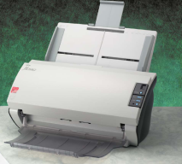Fujitsu FI-5530C2** support A3 paper size. Estimated price ex USA is USD$2500, but greater from Australia. Good for a medium and high loads of scanning. Can scans more pages per minute than the Canon.

|  |  |
| --- | --- |
| Ricoh IS33ODC - Estimated price ex USA $2500USD, more expensive from Australia (check voltage if purchasing from US) Features: Better document feeder, manages large A3 logsheets, but more expensive and takes up a lot of table room in small offices. |  |

# SLOPS: SPC’s scanning software

Introduction

SLOPS is a scanning software developed by SPC for SPC member-country fisheries departments. It has been designed specifically for the scanning of fisheries data, so that these data can be sent to SPC in electronic format for data entry. The idea of SLOPS is to simplify this process by removing the complicated options presented by other scanning packages, and simplify the organization of the scanned documents. SLOPS can be used to scan other types of data, but other scanning software may be more appropriate for some scanning applications.

Installing SLOPS

The SLOPS software file can be supplied to your office by email. The image below is an example of the software’s installation image



1. When you **double- click** on the icon you will get this window.



1. Just click on the ‘Next’ button.



1. You will be asked where you want to install the file. The default location is C:\TUNA\_DBS
2. If you are happy with the location, click on ‘Install’, otherwise change the location by clicking on ‘Browse’.



1. The last task is to click on the finish button. The scanning software will open automatically.

Using SLOPS

Once SLOPS is installed, it is accessible from the Windows Start Menu under Start->OFP Systems->Slops. Installation will also place a shortcut to SLOPS on the desktop. When the program is run, you will see a window like the one shown below with 3 buttons.

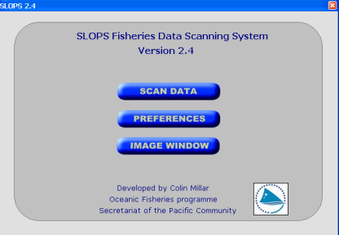

Normally you will just click on ‘Scan Data’, but you should understand what the other options do.

* Scan Data

Opens the main SLOPS scanning interface, for scanning documents.

* Preferences

Opens the preferences screen for setting preferences such as the default location for saving data and the default scanner.

* Image Window

Opens the image window for viewing image files and previously scanned and saved documents.

# SLOPS: Preferences Window

If you are using SLOPS for the first time you should select Preferences to set up you scanning system.

The Preferences screen contains one information-only setting and five information settings.

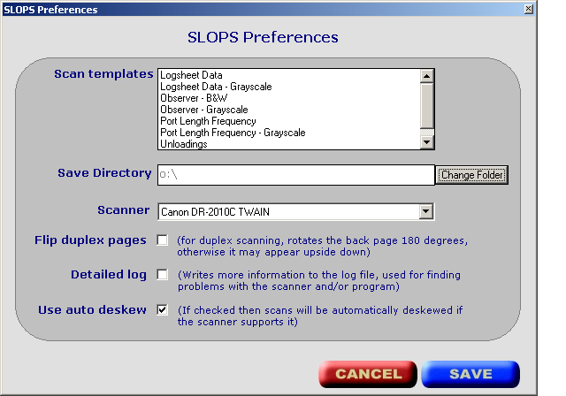

Scan Templates

This is a list of the data templates in SLOPS. Templates define the default image setting like the resolution, brightness and whether the scan will be in black and white or greyscale. Each scan template will also set up what information the user has to enter before they scan like the name of the folder and the name of the file.

Save Directory

This allows you to choose the main folder on your computer or the network where all data scanned by SLOPS will be saved. Each template has its own sub-folder, so if logsheet data were scanned, they would be saved to the ‘C:\TUNA\_DBS\Slops 2\Log’ folder with the setting shown below. The default save directory can be changed by clicking on the ‘Select New Save Folder option’.

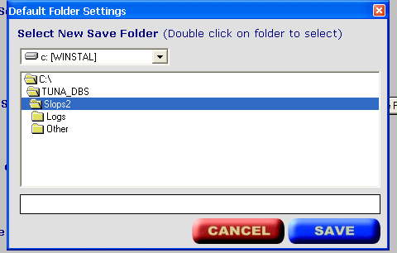

Choose the drive with the top combo box, and the folder from the list box underneath. You must double-click on the folder to select it and you will see the full path in the text box at the bottom of the screen. Click on ‘Save’ to save the settings as default. All future scans will be saved under the newly selected folder. Note that you cannot create a new folder from this window, you should use Explorer to create a new folder beforehand.

Scanner

Use this combo box to select the default scanner. If there are no scanners in the list then this means you have no TWAIN driver installed for the scanner, or the scanner is not connected if the scanner has a USB connection. It is very important that you choose the correct scanner from the list, otherwise the software may not work. Contact SPC for further advice if required. Once you have selected a scanner, click on the ‘Save’ button to save this scanner as default. You should only have to do this once.

Flip duplex pages

Tick this option if you are scanning duplex pages (pages with information on the front and back). Most data forms will be one-sided, but observer written reports are one type of data that will have pages on both sides.

Detailed log

Tick this option if you are having a problem with scanning and don’t understand what the problem is. Normally this box will be left un-checked, but you can tick it if someone from SPC is helping you resolve your scanning problems and asks you to tick this option.

Use auto deskew

If this option is checked your scans will be automatically adjusted / re-positioned if they get twisted a bit as they feed through the scanner. By ticking this option SLOPS will adjust images that have become distorted.

# SLOPS: Scan Data Window

To scan, you must first have selected and saved the default scanning area and default scanner (this only has to be done once, when the program is run for the first time). To open the scanning window, click on the ‘Scan Data’ button on the main screen. The items on this screen are described below:

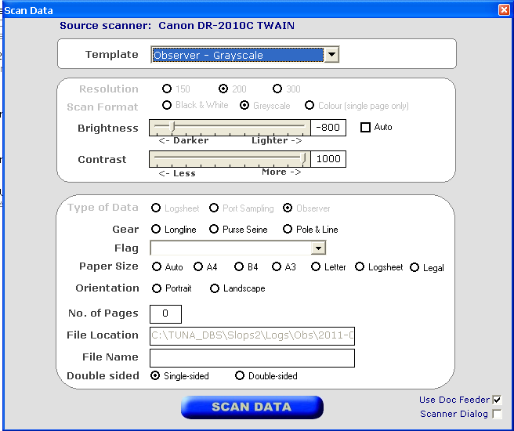

Source scanner

This if for your information only, and displays the selected scanner.

Template

To scan, you must first select a template. The templates are in fact pre-determined settings to help you get the best scanning result. Depending on the template the image resolution, scan format, final file location will change automatically. Templates are done by tuna data type (i.e. logsheet/ port sampling data etc).

Resolution

This sets the scanning resolution in DPI (dots per inch). As resolution increases the size of the image increases the quality of the scan increases and the size of the file increases. Resolution is set for all templates except for ‘custom’.

Scan Format

This defines the format of the resulting image. There are 3 formats to choose from; black and white, greyscale, and colour. The advantages and disadvantages of each are shown below.

|  |  |  |  |
| --- | --- | --- | --- |
| Format | # Colours | Advantages | Disadvantages |
| Black and white | 2 | Smallest file size  Fast scanning speed | Lowest detail  Poor results with dirty pages or light pencil |
| Greyscale | 16 shades of grey | Moderate file size  Good results with dirty pages or light pencil | Slower scanning speed  Files 4 times larger than black and white, so not so good for sending by FTP |
| Colour | 16,777,216 | Excellent results with full colours | Very larger file size  Not practical for scanning large numbers of pages |

Brightness

This is the amount of light in the image or it can also be thought of as the amount of black in the image. The brightness setting is most important for black and white images. Setting brightness to a negative setting will result in a darker image, setting to a higher value will result in a lighter image. You can modify the brightness by using the mouse to move the slider, or by using the cursor keys once the slider is selected. If the page is dirty then you may need to set the brightness lower to avoid black blobs on the scan, while you may need to set the brightness to a high value to scan pages filled in with light pencil. If your scanner supports automatic brightness then you can check the ‘Auto’ box to have the scanner determine the brightness for each page. The best way to get a feel for brightness settings is to experiment, and watch the results for different brightness settings. When scanning in black and white, some pages may need to be scanned again so you should always review the scans before sending them to SPC.

Contrast

Is the relative difference between the light and darkness in an image? It may also be thought of as the amount of shading in a picture.

Scan Format

This defines the format of the resulting image. There are 3 formats to choose from; black and white, greyscale, and colour. The advantages and disadvantages of each are shown below:

|  |  |  |  |
| --- | --- | --- | --- |
| Format | # Colours | Advantages | Disadvantages |
| Black and white | 2 | Smallest file size  Fast scanning speed | Lowest detail  Poor results with dirty pages or light pencil |
| Greyscale | 16 shades of grey | Moderate file size  Good results with dirty pages or light pencil | Slower scanning speed  Files 4 times larger than black and white, so not so good for sending by FTP |
| Colour | 16,777,216 | Excellent results with full colours | Very larger file size  Not practical for scanning large numbers of pages |

Type of Data

This is generally set by the template, and shows whether the data being scanned are logsheets, port sampling data, or observer data.

Gear

The gear type for the data being scanned.

Flag

The vessel nationality for the data being scanned.

Paper Size

Choosing the correct paper size is important so that the resulting scan contains the full page and is not too big. If your scanner supports automatic paper detection then you will be able to select the ‘Auto’ option, otherwise you will have to organize scans by paper size and choose the correct paper size manually.

No. of Pages

Enter the total number of pages to be scanned here.

File Location

This indicates the folder where the file will be saved. This is automatically determined and is dependent on the default save directory and the chosen template.

File Name

This is the filename of the resulting file. For some templates this is automatic and you will see ‘Auto’ when the template is selected, but for others the filename must be entered manually.

Double Sided

Enable this check-box to scan both sides of the documents. You will not need this for scanning logsheets but some data such as observer data have information on both sides of the page. If the scanner doesn’t support duplex scanning then this option will be disabled.

Use the Doc Feeder

Checking this box will enable scanning from the automatic document feeder. If un-checked then the scanner will use the flatbed as the source.

Scanner Dialog

Checking this box will open the scanner dialog box before the scan is made. This will enable you to access the more advanced settings of the scanner, and is only recommended if you are scanning a different type of document using the ‘custom’ template.

# Start the Scan

Scanning a batch of data requires some preparation and some careful attention before, during, and after the scan. Please see page 5.

Once you have selected the template and filled in the other relevant information on the scanning setup page, click on ‘Scan Data’ to start the scan. The first page will be scanned and the scanned image displayed in the Image Window:



Look carefully at the scan to make sure it is clear and easy to read. You can rotate and zoom the image to make it easier to view. If you are not happy with the scan, you can close the window and the scan will not be saved.

**Remember what you can see on your screen is the same that SPC can see on their screen.**

**Are you sure the scan on your screen is legible?**

If you are happy and want to continue, then position the scanned image in a way that you can see an important area of the page (e.g. the trip information for a logsheet), and click on the ‘Save and continue’ button. The rest of the pages in the document feeder will be scanned, with each image zoomed, rotated, and positioned in the same way as the first scan so that you can visually see if each page is scanning well. When the document feeder is empty the last image will be displayed. You should verify that the number of pages scanned match the number of documents placed in the feeder. You can add more pages to the current file by putting more documents into the document feeder and clicking on the ‘Add more pages’ button. Only add more pages if they are from the same batch, each batch should be scanned as a different file. Additional pages are saved directly to the file.

# SLOPS: Image Window

The image window is mainly used for viewing scanned data (TIF files), but can be used to view other types of graphic files such as jpg and gif files. The Image Window can be launched from the main SLOPS screen, and will open automatically during the scanning process. This section describes the general features of the Image Window.

For details on how to use the Image Window during scanning, see the ‘Scanning with SLOPS’ section.



Features of the Image Window

With the Image Window you can:

* Open an image file
* Rotate images
* Zoom in or out
* Navigate between pages for multi-page TIF files (i.e. scanned documents)

These functions are available from two areas, from the status bar at the bottom of the window by clicking in the appropriate information area, and by right-clicking in the image area. Note that these functions don’t modify the original file, they are for display only.

The status bar on the bottom of the window shows 5 pieces of information (from

left to right):

* Page x of x – for multi-page TIF files this will show the currently displayed page and the total number of pages in the file.
* Filename – the filename of the currently displayed image.
* Image information – the width x height x bit depth of the current image.
* Zoom – The current level of zoom or type of fit to the image window.
* Rotation – The current level of rotation

Opening / editing a file

You can open a file by right-clicking on the image area and selecting ‘Open’, or by clicking in the second status box in the status bar (where it shows ‘No image loaded’ in the screenshot above). Use the next window to navigate to the image you want to open and click ‘Open’. You can choose ‘Edit TIF file’ instead of ‘Open’, to open a TIF file in Edit mode. This means that you will be able to delete individual pages from the file.

Rotating Images

Images can be rotated 90º left (anticlockwise), 90º right (clockwise), 180º, and restored to the original position. These are accessible by clicking in the rotation area of the status bar or by right-clicking on an image. The degree of rotation is kept when changing pages in a multi-page image and when loading a new image.

Zooming

There are several options for zooming with an image, accessible from the zoom area on the status bar or by right-clicking on the image:

* Zoom by percentage – there are several preset zoom levels to choose from (25%, 50%, 75%, 100%, 125%, 150%, 200%)
* Fit Width – resizes the image so that the full width of the image is visible in the image window.
* Fit Height - resizes the image so that the full height of the image is visible in the image window.
* Best Fit to Window - resizes the image so that the entire document fits into the image window with the document proportion kept intact.
* Stretch to Window - resizes the image so that the entire document fits into the image window. The Entire window will be used, so that the document may not retain its original proportions. The degree of zoom is kept when changing pages in a multi-page image and when loading a new image.

Scrolling within an Image

If an image is bigger than the image window, you can scroll either by using the scroll bars, or by using the left mouse button to click in the image window and drag the image in the direction you wish.

Navigating within Multi-page TIF files

When a multi-page TIF file is open, you can change pages by accessing the following functions from the page area of the status bar or by right-clicking in the image window:

* First page – go to first page in file
* Previous page – go to previous page in file
* Next page – go to next page in file
* Last page – go to the last page in file
* Delete page – delete the current page

**Shortcut keys**

You can perform some of the actions above with the keyboard:

* L – Rotate left 90 º (anti-clockwise)
* R – Rotate right 90 º (clockwise)
* 0 – Zoom to 100%
* 1 – Zoom to 10%
* 2 – Zoom to 20%
* 3 – Zoom to 30%
* 4 – Zoom to 40%
* 5 – Zoom to 50%
* 6 – Zoom to 60%
* 7 – Zoom to 70%
* 8 – Zoom to 80%
* 9 – Zoom to 90%
* Page Up – Go to previous page in multi-page TIF file.
* Page Down – Go to next page in multi-page TIF file.

Templates

Templates are designed to make scanning simpler and to provide consistent scan

settings for particular types of data. Templates can determine the following:

* The resolution of the scan
* The scan format (or scanning mode)
* The type of data
* Whether or not extra information is required (e.g. gear and flag)
* The file location. This has 2 components; a sub folder of the default save folder, and then it is possible to have a folder for each month. For example, if the folder by month option is set for logsheets, then the file location for documents scanned in August 2005 will be ../LOG/2005-08/, and in September there will be a new folder created called /LOG/2005-09/.
* File name – can be automatically generated.
* Default brightness

At present, there are 6 templates available, shown below. These are easily created so if you need more then contact SPC:

|  |  |  |  |  |  |  |
| --- | --- | --- | --- | --- | --- | --- |
| **Template name** | **Logsheet** | **Observer (B&W)** | **Observer -greyscale** | **Port length frequency** | **Unloadings** | **Custom** |
| **Folder** | Log | Obs | Obs | Lf | UW | Other |
| **Auto filename** | Yes | No | No | Yes | Yes | No |
| **File prefix** | Log | - | - | LF | UW |  |
| **Resolution** | 300 | 300 | 200 | 300 | 300 | 300 |
| **Default brightness** | 0 | -30 | 30 | 0 | 0 | 0 |
| **Format** | Black & White | Black & White | Black & White | Black & White | Black & White | Black & White |
| **Data type** | Logsheet | Observer | Observer | Port sampling | Port sampling | - |
| **Month folder** | Yes | Yes | Yes | Yes | Yes | No |
| **Flag required** | Yes | Yes | Yes | No | No | No |
| **Gear required** | Yes | Yes | Yes | Yes | Yes | No |

# Getting SLOPS Support

If you have any problems using this software, or any suggestions for improvement, please send by e-mail to colinm@spc.int. For error reports, please include as many details as you can, such as what you were doing, and the exact error message. A screenshot is often the easiest way to show what has happened exactly (take a screenshot by pressing the ‘Print Screen’ button on the keyboard and then pasting the image into an e-mail or a graphics program.

# Backing up your electronic scans

Backing up data – why you need to do it and how to do it

Everyone has heard of it, but what exactly does it mean to backup data? It is the process of making a copy of a file or files, whether it be a single document, database, or folder of thousands of files. The purpose of making a copy is to prevent ‘data loss’, which is when you lose a file or files that contain important data or information. Backing up data is one of the most important, yet one of the most neglected, areas of computing. It should be at the top of everyone’s computer maintenance list, along with virus protection.

How can data be lost?

Unfortunately there are many ways in which you can lose data:

* By accidentally deleting a file, or even a folder.
* By losing the ‘media’ (e.g. disk, USB drive, portable hard drive, laptop, etc) that the files are on. Losing includes being stolen.
* Virus attack.
* Software problems, such as corruption of the file while editing it in Microsoft Word, or using a database in Microsoft Access.
* Electrical problems or power cuts
* Physical failure of the media storing the data.

All of these are common occurrences and can happen to anyone, at any time, and there are even more ways of losing data than this list. One of the worst is the last one, media failure. This refers to when the media, such as a hard disk or CD, fails and can no longer be read. Hard disk drives are sometimes categorized into 2 groups, disk drives that have failed, and disk drives that will fail. It may take many years, but a computer’s hard drive will eventually fail and you may lose all of the data on the drive. It can happen gradually, or suddenly and without warning. It has happened to me more than once, but luckily I had backups of the data so the result was not so bad. Don’t think that a new hard drive is safe, many new drives fail as well as old.

How to back up

If you backup well then losing data will not have such a devastating effect. Imagine if you enter data for several years into TUFMAN, and one day lose all of the data because the hard disk storing TUFMAN dies. With no backup you will have to enter all of the data again, which would take years, whereas if you had backed it up you may only lose one day or maybe one week’s worth of data, depending on when the last backup was made.

Backing up means to keep a copy of important files in a separate location, in case the originals are lost. Keeping a copy of a file on the same hard disk as the original is not a good idea because the whole hard drive might fail, it should be physically separate for the backup to be effective. Some good places to backup your files are as follows:

* To a server backup - Most network servers are setup with a regular back-up system, e.g. tapes, and will backup certain folders on the network at least once a week. If your office does this, then storing your important files in an area of the network that is backed up is a great way to secure your data. Don’t just leave your important files on the C: drive of your computer or laptop. If your office has a server with a backup system, make sure that it is functioning and regular backups are being taken.
* To another hard drive – e.g. to an external hard disk, or another computer on the network.
* Onto CD or DVD – copying files onto a CD or DVD is not a bad way to backup data. The only thing to be aware of is that CD’s and DVD’s do not last forever. Some brands may last for 100 years, but some of the cheaper CD’s and DVD’s will not last such a long time, and they can also be damaged or scratched making them unreadable. If the same backups are made once per week or so then CD/DVD failure this is less of a problem, but if you put all of your photos on a DVD and expect the DVD to last 50 years, you may be disappointed.
* Others – there are other ways to backup data, such as zip drives, memory sticks, and there are even some online backup services. For TUFMAN, SPC holds a copy of your database, so if you regularly send a copy of the data files to SPC, it is a form of backing up your data.
* The best way to backup data is to store the copies as far away as possible, e.g. in another building. This way, if your office building burns down or is flooded, the backups will not be destroyed.

Conclusion

If you don’t backup your data, now is the time to start. You should backup any file that you don’t want to lose, because unfortunately every file is at risk of being lost and no storage media is risk free. It may take some time to do and seem boring and pointless, but one day your backups will save you many days, even years, of your work. If you want the backup process to happen automatically, you can get a backup program that does the backup on a regular basis and lets you schedule the backups with several different options. Last, remember to back up regularly. You don't want to have something happen to your data, then restore your backup just to realize it is 6 months old. Depending how much work you do, back up either weekly or at least monthly.

# 

# Transferring scanned data

# 

The most efficient method for transferring scans to SPC is to use the **OFP data reception dropbox.**

This online service is accessible through the following web address: [**https://dropbox.hightail.com/ofpdatareception**](https://dropbox.hightail.com/ofpdatareception)

This web interface will allow you to send any number of scans to us. The main advantages of this dropbox is that each of the scans you send is sent to us as a Hightail shortcut , which we can then use for downloading your files. This has several advantages:

* No saturation of email boxes
* No email rejection - SPC email boxes are limited to receive a maximum of 8Mb in each email.
* No need to remember who exactly you have to send the data to – it’s always the same dropbox from now on where you have to send your data to.
* Dropbox is monitored by several persons in OFP
* Our data registry officer can downloads, registers, and acknowledge reception of data from the dropbox
* The dropbox allows us to keep track of data submitted.

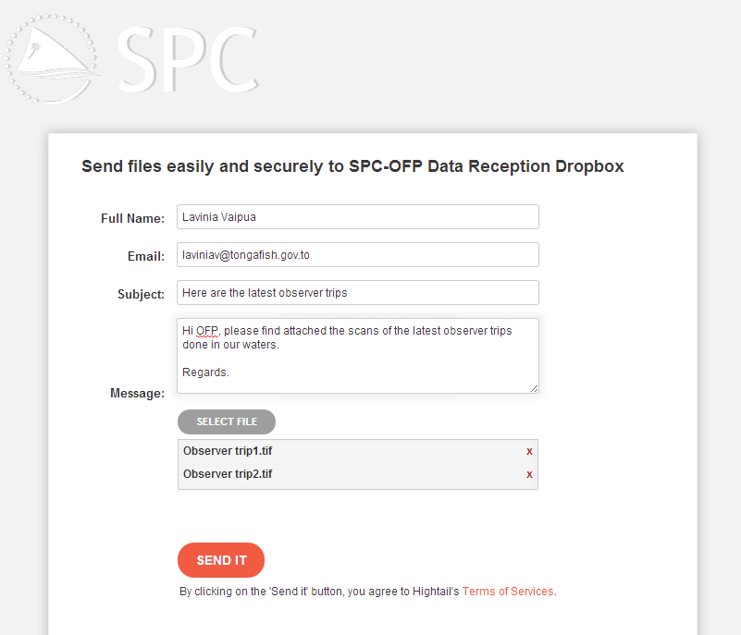

**How Does the dropbox interface work ?**

You just have to fill in the main fields displayed on the interface, and then select the files you want to transmit

* **Full Name**: enter your own name, so that we know who is sending the data
* **Email**: enter your email address
* **Subject**: summary of what you are sending. A mention of your country would be appreciated, although not required.
* **Message**: a small description of the data files, but no need to go into too many details. Should you be transferring TUFMAN backup files, you might want to ask us whether we can update your eRecon database if it is the purpose of the transfer.
* : Click on this and select as many files as you wish to transfer, into this unique message.
* : once finished, click on send it to complete the transfer process.

# 

# An alternative: Physically transferring data

C:\Documents and Settings\deirdreb\Local Settings\Temporary Internet Files\Content.IE5\SUFY3X3J\MCj04260700000[1].wmfThe last method for sending electronic data to SPC is by first copying the data onto a carrier media (i.e. USB key, CD, DVD etc). This can be physically transferred to SPC by sending it by mail or by transferring it by hand etc. This method may take a lot more time, but it may be the only solution for transferring data electronically if your office does not have a good internet connection.

# Common problems with scanning.

* Scanning incomplete – Pages missing
* Scans not visible
* New software improvements offered, but not installed
* Use 2B pencils for sampling data
* Normally, if it is visible on the screen, it will be visible on the print out. Check the scans on your computer before sending!
* Not paying special attention needs to be paid to waterproof paper.
* Technical breakdowns not resolved for long periods.
* Data scanned, but data not transferred to SPC.
* Data never scanned physical folders in hiding (or placed in a different area)!
* Observer pages numbered incorrectly
* Observer data not properly debriefed (data sheets missing etc).
* Scanning both sides of the page (we don’t need the instructions!)
* SLOPS doesn’t work with Windows Vista